**Counts Callout**

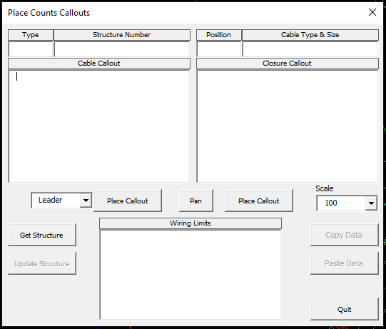

Once you have clicked on Get Structure and selected a block with counts, cable information, splices, and customers fed from this location will be displayed. Note: if the drawings have been cut out or permits created, you will get multiple copies of the customers in the Wiring Limits.

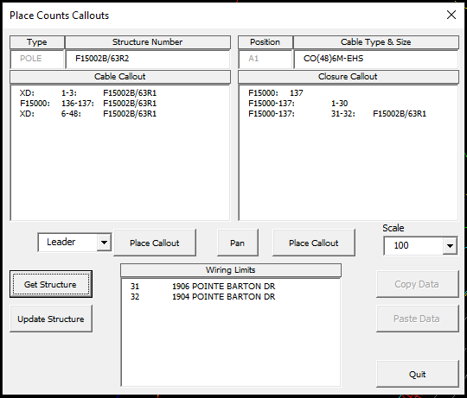

You can manually change anything in these fields that are editable. Note: there are no spaces in the Callout textboxes. Use Tabs to separate the data. Note: the program does not validate the data you change. If the counts are off-color or more than the cable size, it will stay that way. Hope to add this function soon.

There is a Place Callout button below Cable Callout and Closure Callout. The one below Cable Callout gives you an option to place a leader line or an away callout. Note: the cable callout is for the back span. (Toward the C.O.)

Below are the examples:

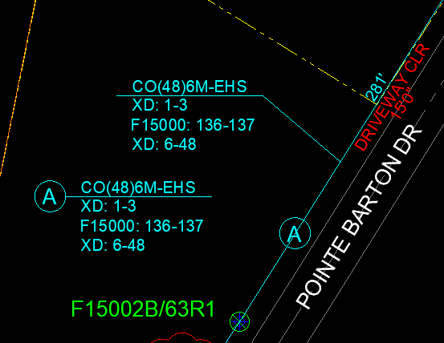

For both options, you will be prompted to select a point on the cable, then the place you want the callout. Note: you will need to trim the lines within the circle if an away callout.

For a closure callout, it will only place a leader line starting from the structure. You will only be prompted for where you want the callout placed.

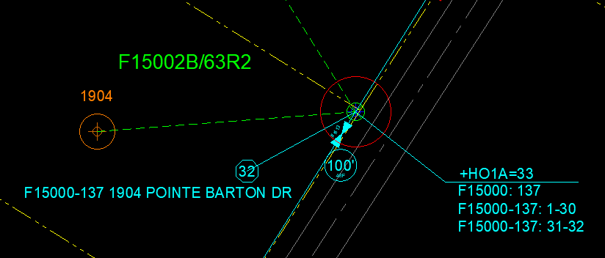

The HO1 type will be determined by the block type. If it is a pole, HO1A will be the type; the rest will be HO1B. The number spliced will be calculated from the fibers spliced in the callout.

If you have made changes to the cable or closure data, click Update Structure to save the changes in the block.